**Scheme**

1. **Introduction to scheme.org**Schema.org takes care of all the structured data needs on your website. Search engines like Google can pick up this data and present your page in an enhanced way if you use it to describe products, reviews, events, and recipes.  
    The major search engines, Google, Bing, Yandex, and Yahoo, collectively developed this vocabulary to reach a shared language to understand websites better.  
   example :  
   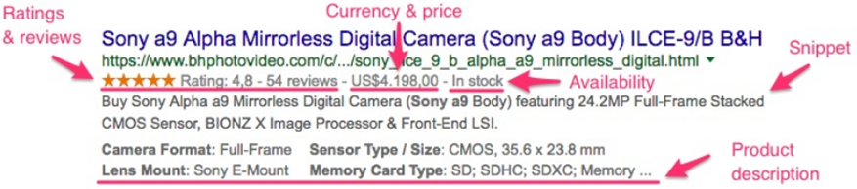  
   Note: when we prepare the scheme Object once, it will appliacble for web and ipad and mobile screen also , so no need of writing the scheme Object for each media screeen  
   that one scheme Object for all screen

* **All About Scheme  
  a)** scheme m chesthadi anthi, Google ki infromation echesthadi about our website, so google work load thaguthadi i.e google don’t go into our website content , it just use the scheme Object for displaying the rich snippets in the google search and google use these scheme infromation for Google maps and reviews, and etc  
  **b)** there are many different way for preparing scheme, like writing for the hotols, airlines and e-commmerance website,   
  NOTE: all of them as follow same stand approch, just the text and content will changes, we must write the content and text according the content which we are preapring and taking the help of Offical documenets of scheme.org and google  
  **c)**  Use structured data markup on your product landing pages to help Google retrieve up-to-date information about your products and offers directly from your website.  
  **d)** Here we state(and this is the very least you should include):   
   1. The type of company   
   2. The company name   
   3. Official website   
   4. Address  
   5. The official logo   
   6. The preferred description   
   7. The social accounts   
   8. The unique identifying URL  
  **e)** The process is really simple - you just choose the Schema type like recipe or hotel or Organization and mark all the needed elements on your webpage. And Use structured data markup on your product landing pages to help Google retrieve up-to-date information about your products and offers directly from your website.  
  **f)** JSON-LD format is a more popular method of adding Schema markup manually. What's more, this method is recommended by Google. It's also easier to understand and deploy than Microdata or other outdated formats like RDF or Microformats.
* **3rd party website provide a service to prepare the Scheme  
  a)** 3rd party site generate the scheme Object file for us, by just providing the basic information about our company or website  
  **b)** some of website links are  
   1) <https://technicalseo.com/tools/schema-markup-generator/>   
   2) <https://hallanalysis.com/json-ld-generator/>   
   3) <https://www.rankranger.com/schema-markup-generator>   
   4) <https://technicalseo.com/tools/schema-markup-generator/>
* **Offical website for scheme Preparation and refrence**

1. scheme offical website validator : <https://validator.schema.org/>
2. Google rich testing tool : <https://search.google.com/test/rich-results>
3. Google scheme Guidelines : <https://developers.google.com/search/docs/advanced/structured-data/recipe>
4. Officalwebsite of the microData : <https://html.spec.whatwg.org/multipage/microdata.html#microdata>

* **Some of Examples**

1. 
2. 
3. 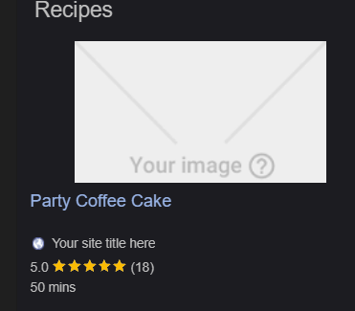
4. 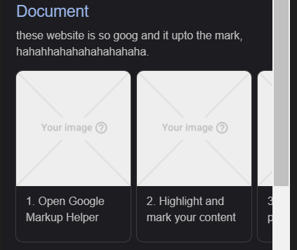

* **Scheme Overview**

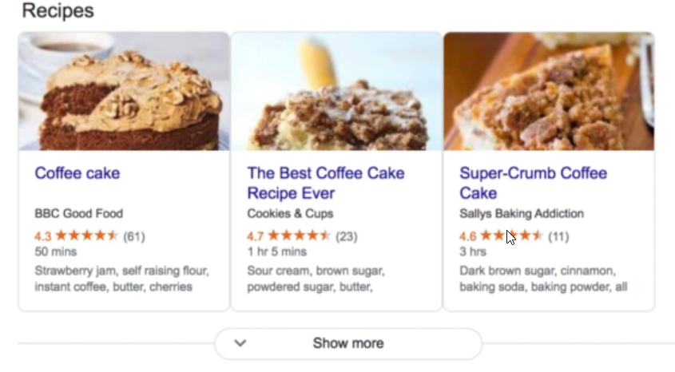

1. we dont have any html tag to write these kiind of results   
   so by using the scheme data we can achieve these kind of resullts in our code   
   so we use scheme Object to prepare like these
2. Structured data is a standardized format for providing information about a page and classifying the page content.

* **Scheme benefits**

1. Add additional semantic to page content I
2. mprove the accuracy of the result I
3. ncreases the accuracy of site indexing by search engines
4. Increase CTR

* **Types of preparing the scheme Objects**

There 3 types of preparing the scheme Object

1. **RDFA format**
2. Intro  
   W3C Specification  
    Uses attributes to integrate chosen vocabulary.   
   Closely marry to microdata RDFa Lite is smaller subset of RDFa designed to be easier to use.
3. Example
4. <**li** property="recipeInstructions" typeof="HowToStep" vocab="https://schema.org/">
5. <**span** property="text">Preheat the oven to 350 degrees F. Grease and flour a 9x9 inch pan.</**span**>
6. </**li**>
7. **Micro-data format**
8. Intro  
   Originally introduced by WHATWG HTML5 Group.  
    Uses attributes to create name/value pairs that identify content.   
   Study done by webdatacommon says that 50.5% websites uses microdata to structure their pages.   
   First to adopted by google, bing, yahoo and yandex as the preferred structured data syntax.
9. **example**

     <**div** itemscope itemprop="mainEntity" itemtype="https://schema.org/Question">

                <**h3** itemprop="name">Who is the author of this recipe?</**h3**>

                <**p** itemscope itemprop="acceptedAnswer" itemtype="https://schema.org/Answer">

                  <**span** itemprop="text">

                    Lorem ipsum dolor sit amet consectetur adipisicing elit. Eius voluptatibus molestiae quam sed

                  </**span**>

                </**p**>

              </**div**>

1. **JSON Format**
2. Intro  
   Uses JSON to store structured data in embedded scripts.  
    Abstracts the data from the structure of the web page.   
   W3C Specification Google's favorite syntax to markup your site.
3. Example
4. {
5. "@context": "https://schema.org/",
6. "@type": "Event",
7. "name": "The Adventures of Kira and Morrison12",
8. "description": "The Adventures of Kira and Morrison is coming to Snickertown in a can’t miss performance.",
9. "image": "http://www.lacm.edu/wp-content/uploads/2017/03/kira-morrison-lacm-recital-march-17-2017-6451-uai-1800x1199.jpg",
10. "startDate": "2022-03-03",
11. "endDate": "2022-03-03",
12. }

* **Micro-Data Format Real Code Example**

1. Code
2. <!**DOCTYPE** html>
3. <**html** lang="en">
4. <**head**>
5. <**meta** charset="UTF-8" />
6. <**meta** name="viewport" content="width=device-width, initial-scale=1.0" />
7. <**meta** http-equiv="X-UA-Compatible" content="ie=edge" />
8. <**link**
9. rel="stylesheet"
10. href="https://stackpath.bootstrapcdn.com/bootstrap/4.3.1/css/bootstrap.min.css"
11. />
12. <**title**>Delicious Party Coffee Cake</**title**>
13. </**head**>
14. <**body** class="mt-3">
15. <!-- Page Content -->
16. <**main** class="container" itemscope itemtype="https://schema.org/Recipe">
17. <!-- Article Section -->
18. <**article**>
19. <!-- // explaniation
20. itemscuope is scope of the item , till the tag ends
21. -->
22. <!--
23. itemtype is the type of caterofry we are going to use in our scheme, currenntly we are using the Recipe so we keep the recipe
24. -->
25. <**header**>
26. <**h1** itemprop="name" class="text-success">
27. <!-- here itemprop means the property of the item(Recipe currently) -->
28. Delicious Party Coffee Cake
29. </**h1**>
30. <**p**>
31. Recipe author:
32. <**span**
33. itemscope
34. itemtype="https://schema.org/Person"
35. itemprop="author"
36. >
37. <**span** itemprop="name"> Mary Stone </**span**>
38. </**span**>
39. <!-- itemprop of recipe author -->
40. </**p**>
41. <**p**>
42. <**meta** itemprop="datePublished" content="2021-09-28" />
43. Date published: March 16, 2020
44. <!-- dataof publisted which present in the recipe property -->
45. </**p**>
46. <**p** itemprop="description">
47. This coffee cake is awesome and perfect for parties.
48. </**p**>
49. <**img**
50. itemprop="image"
51. src="https://cdn.pixabay.com/photo/2019/09/24/21/49/cake-4502270_1280.jpg"
52. height="300"
53. alt="Party Coffee Cake"
54. />
55. </**header**>
56. <**section** class="mt-4">
57. <!-- recipeYield -->
58. <**h5**>Yield: <**span** itemprop="recipeYield"> 10 servings </**span**></**h5**>
59. <!-- https://en.wikipedia.org/wiki/ISO_8601 -->
60. <!-- P3Y6M4DT12H30M5S -->
61. <**h5**>
62. Prep time:
63. <**meta** itemprop="prepTime" content="PT20M" />
64. 20 minutes
65. </**h5**>
66. <**h5**>
67. Cook time:
68. <**meta** itemprop="cookTime" content="PT20M" />
69. 30 minutes
70. </**h5**>
71. <**h5**>
72. Total time:
73. <**meta** itemprop="totalTime" content="PT20M" />
74. 150 minutes
75. </**h5**>
76. <**h5**>
77. Category:
78. <**span** itemprop="recipeCategory"> Cake </**span**>
79. </**h5**>
80. <**h5**>
81. Recipe Cuisine:
82. <**span** itemprop="recipeCuisine"> French </**span**>
83. </**h5**>
84. <**h2** class="text-success">Ingredients</**h2**>
85. <**ul**>
86. <**li** itemprop="recipeIngredient">2 cups of flour</**li**>
87. <**li** itemprop="recipeIngredient">3/4 cup white sugar</**li**>
88. <**li** itemprop="recipeIngredient">2 teaspoons baking powder</**li**>
89. <**li** itemprop="recipeIngredient">1/2 teaspoon salt</**li**>
90. <**li** itemprop="recipeIngredient">1/2 cup butter</**li**>
91. <**li** itemprop="recipeIngredient">2 eggs</**li**>
92. <**li** itemprop="recipeIngredient">3/4 cup milk</**li**>
93. <**li** itemprop="recipeIngredient">1 teaspoon vanillaextract</**li**>
94. <**li** itemprop="recipeIngredient">1 1/2 teaspoon group cinnamon</**li**>
95. </**ul**>
96. <**h2** class="text-success">Directions</**h2**>
97. <**ul**>
98. <**li**
99. itemprop="recipeInstructions"
100. itemscope
101. itemtype="https://schema.org/HowToStep"
102. >
103. <**span** itemprop="text">
104. Preheat the oven to 350 degrees F. Grease and flour a 9x9 inch
105. pan.
106. </**span**>
107. </**li**>
108. <**li**
109. itemprop="recipeInstructions"
110. itemscope
111. itemtype="https://schema.org/HowToStep"
112. >
113. <**span** itemprop="text">
114. Make the streusal topping. In a medum bowl, combine flour,
115. sugar, and cinnamon. Mix in butteruntil the entire mixture is
116. crumbly.
117. </**span**>
118. </**li**>
119. <**li**
120. itemprop="recipeInstructions"
121. itemscope
122. itemtype="https://schema.org/HowToStep"
123. >
124. <**span** itemprop="text">
125. In a large bowl, combine flour, sugar, baking powder, and salt.
126. Mix in the butter. Mix in the milk, egg, and vanilla. Spread
127. into the prepared pan.
128. </**span**>
129. </**li**>
130. <**li**
131. itemprop="recipeInstructions"
132. itemscope
133. itemtype="https://schema.org/HowToStep"
134. >
135. <**span** itemprop="text">
136. Sprinkle the streudal mixture on top of the cake.
137. </**span**>
138. </**li**>
139. <**li**
140. itemprop="recipeInstructions"
141. itemscope
142. itemtype="https://schema.org/HowToStep"
143. >
144. <**span** itemprop="text">
145. Bake for 30 to 35 minutes, or until firm. Allow to cool.
146. </**span**>
147. </**li**>
148. </**ul**>
149. <**h2** class="text-success">Nutrition facts</**h2**>
150. <**p**
151. itemprop="nutrition"
152. itemscope
153. itemtype="https://schema.org/NutritionInformation"
154. >
155. Per slice :
156. <**span** itemprop="calories">2701</**span**> calories;
157. <**span** itemprop="fatContent"> 12</**span**> g fat;
158. <**span** itemprop="carbohydrateContent"> 37</**span**> g carbohydrates;
159. <**span** itemprop="proteinContent">2</**span**> g protein;
160. <**span** itemprop="cholesterolContent"> 45</**span**> mg cholesterol;
161. <**span** itemprop="sodiumContent">1 95</**span**> mg sodium.
162. </**p**>
163. <**h2** class="text-success">Keywords</**h2**>
164. <**p** itemprop="keywords">Coffe Cake, Party Cake</**p**>
165. </**section**>
166. </**article**>
167. <!-- /.row -->
168. <**hr** />
169. <!-- Reviews Section -->
170. <**section**>
171. <**h2** class="text-success">Sample Reviews ★★★★★</**h2**>
172. <**h6**
173. itemprop="aggregateRating"
174. itemscope
175. itemtype="https://schema.org/AggregateRating"
176. >
177. <**span** itemprop="ratingValue">4.9</**span**>
178. out of
179. <**span** itemprop="bestRating"> 5 </**span**>
180. (Total
181. <**span** itemprop="reviewCount">218</**span**>
182. )
183. </**h6**>
184. <!-- list of reviews -->
185. <**article**
186. itemprop="review"
187. itemscope
188. itemtype="https://schema.org/Review"
189. >
190. <**h4** itemprop="author">Mary</**h4**>
191. <**time** datetime="2020-06-06T13:31:04-08:00">
192. <**meta**
193. itemprop="datePublished"
194. content="2020-06-06T13:31:04-08:00"
195. />
196. June 6<**sup**>th</**sup**>, 2020 at 1:31</**time**
197. >
198. <**p**
199. itemprop="reviewRating"
200. itemscope
201. itemtype="https://schema.org/Rating"
202. >
203. Rating: <**span** itemprop="ratingValue">5</**span**>
204. </**p**>
205. <**p**>
206. Review for:
207. <**span** itemprop="itemReviewed">Delicious Party Coffee Cake</**span**>
208. </**p**>
209. <**p** itemprop="reviewBody">This coffee cake is delicious!</**p**>
210. </**article**>
211. <**article**
212. itemprop="review"
213. itemscope
214. itemtype="https://schema.org/Review"
215. >
216. <**h4** itemprop="author">Mary</**h4**>
217. <**time** datetime="2020-06-06T13:31:04-08:00">
218. <**meta**
219. itemprop="datePublished"
220. content="2020-06-06T13:31:04-08:00"
221. />
222. June 6<**sup**>th</**sup**>, 2020 at 1:31</**time**
223. >
224. <**p**
225. itemprop="reviewRating"
226. itemscope
227. itemtype="https://schema.org/Rating"
228. >
229. Rating: <**span** itemprop="ratingValue">5</**span**>
230. </**p**>
231. <**p**>
232. Review for:
233. <**span** itemprop="itemReviewed">Delicious Party Coffee Cake</**span**>
234. </**p**>
235. <**p** itemprop="reviewBody">This coffee cake is delicious!</**p**>
236. </**article**>
237. <**article**
238. itemprop="review"
239. itemscope
240. itemtype="https://schema.org/Review"
241. >
242. <**h4** itemprop="author">Susan</**h4**>
243. <**time** datetime="2020-02-09T13:31:04-08:00">
244. <**meta**
245. itemprop="datePublished"
246. content="2020-06-06T13:31:04-08:00"
247. />
248. Feb 9<**sup**>th</**sup**>, 2020 at 1:31</**time**
249. >
250. <**p**
251. itemprop="reviewRating"
252. itemscope
253. itemtype="https://schema.org/Rating"
254. >
255. Rating: <**span** itemprop="ratingValue">5</**span**>
256. </**p**>
257. <**p**>
258. Review for:
259. <**span** itemprop="itemReviewed">Delicious Party Coffee Cake</**span**>
260. </**p**>
261. <**p** itemprop="reviewBody">
262. The cake instructions are superbly crafted and accurately designed.
263. </**p**>
264. </**article**>
265. <**article**
266. itemprop="review"
267. itemscope
268. itemtype="https://schema.org/Review"
269. >
270. <**h4** itemprop="author">Mark</**h4**>
271. <**time** datetime="2020-07-16T13:31:04-08:00">
272. <**meta**
273. itemprop="datePublished"
274. content="2020-06-06T13:31:04-08:00"
275. />
276. July 16<**sup**>th</**sup**>, 2020 at 1:31</**time**
277. >
278. <**p**
279. itemprop="reviewRating"
280. itemscope
281. itemtype="https://schema.org/Rating"
282. >
283. Rating: <**span** itemprop="ratingValue">5</**span**>
284. </**p**>
285. <**p**>
286. Review for:
287. <**span** itemprop="itemReviewed">Delicious Party Coffee Cake</**span**>
288. </**p**>
289. <**p** itemprop="reviewBody">
290. The cake also includes paprika, which makes me nervous.
291. </**p**>
292. </**article**>
293. <**p**><**a** href="#">(Expand all reviews)</**a**></**p**>
294. </**section**>
295. <!-- /list of reviews -->
296. <!-- Footer -->
297. <**footer** class="mt-5">
298. <**hr** />
299. <**p**>
300. Copyright &copy; Home of the best cakes, 2020 |
301. <**a** href="#" target="_blank" rel="nofollow">Rahul Giri</**a**>
302. </**p**>
303. </**footer**>
304. </**main**>
305. <!-- /.container -->
306. </**body**>
307. </**html**>
308. Example  
     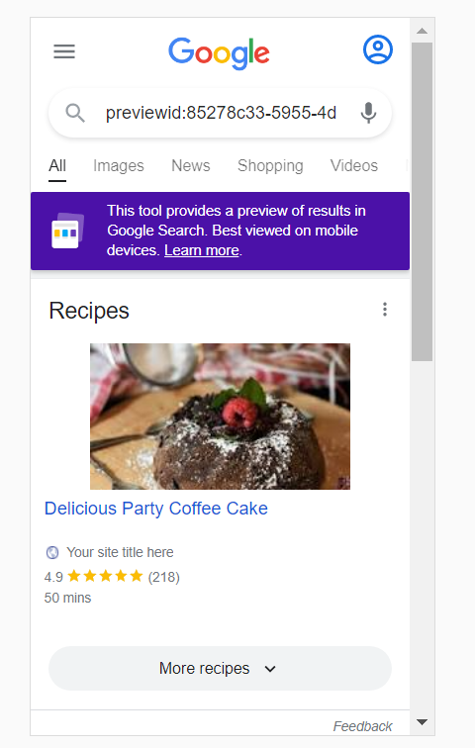
309. **Explanation of code**

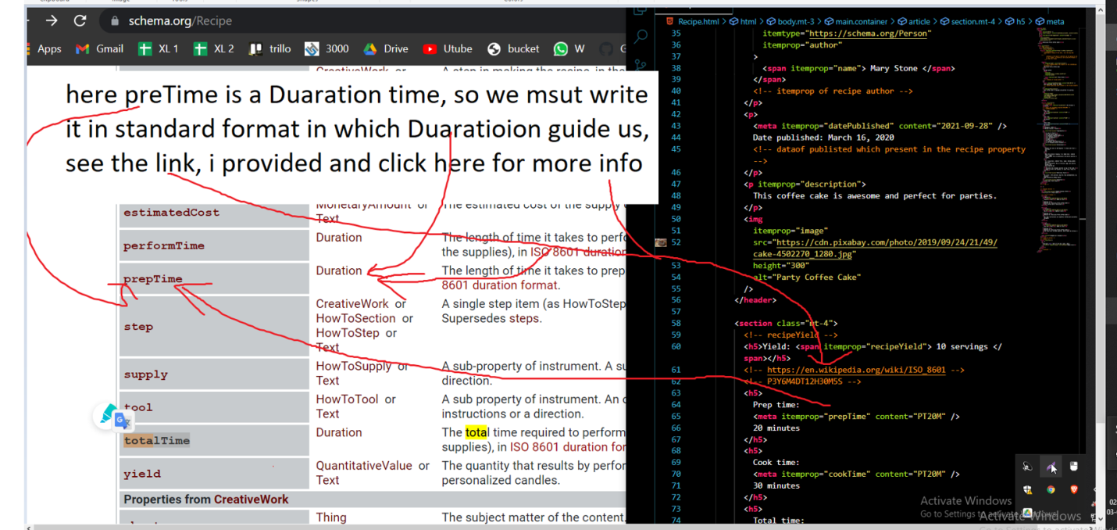

1. There is no specific rule that we must use these one only or not, according to the our website, we will prepare the scheme object, but here name and images are mandtory becoz its recommed by google
2. how do i know that we must use these property only ani, anthi, according the content which we have in our website, we msut search that name in scheme.org website in recipe categroy then we must use that one here anthi

* **JSON-LD Format Real Code Example**

1. Code
2. <!**DOCTYPE** html>
3. <**html** lang="en">
4. <**head**>
5. <**meta** charset="UTF-8">
6. <**meta** name="viewport" content="width=device-width, initial-scale=1.0">
7. <**meta** http-equiv="X-UA-Compatible" content="ie=edge">
8. <**link** rel="stylesheet" href="https://stackpath.bootstrapcdn.com/bootstrap/4.3.1/css/bootstrap.min.css">
9. <**title**>Delicious Party Coffee Cake</**title**>
10. </**head**>
11. <**body** class="mt-3">
12. <!-- Page Content -->
13. <**main** class="container">
14. <!-- Article Section -->
15. <**article**>
16. <**header**>
17. <**h1** class="text-success">Delicious Party Coffee Cake</**h1**>
18. <**p**>Recipe author: Mary Stone</**p**>
19. <**p**>Date published: March 16, 2020</**p**>
20. <**p**>This coffee cake is awesome and perfect for parties.</**p**>
21. <**img** src="https://cdn.pixabay.com/photo/2019/09/24/21/49/cake-4502270_1280.jpg" height="300"
22. alt="Party Coffee Cake">
23. </**header**>
24. <**section** class="mt-4">
25. <**h5**> Yield: 10 servings </**h5**>
26. <**h5**> Prep time: 20 minutes </**h5**>
27. <**h5**> Cook time: 30 minutes </**h5**>
28. <**h5**> Total time: 50 minutes </**h5**>
29. <**h5**> Category: Cake </**h5**>
30. <**h5**> Recipe Cuisine: French </**h5**>
31. <**h2** class="text-success">Ingredients</**h2**>
32. <**ul**>
33. <**li**>2 cups of flour</**li**>
34. <**li**>3/4 cup white sugar</**li**>
35. <**li**>2 teaspoons baking powder</**li**>
36. <**li**>1/2 teaspoon salt</**li**>
37. <**li**>1/2 cup butter</**li**>
38. <**li**>2 eggs</**li**>
39. <**li**>3/4 cup milk</**li**>
40. <**li**>1 teaspoon vanillaextract</**li**>
41. <**li**>1 1/2 teaspoon group cinnamon</**li**>
42. </**ul**>
43. <**h2** class="text-success">Directions</**h2**>
44. <**ul**>
45. <**li**> Preheat the oven to 350 degrees F. Grease and flour a 9x9 inch pan. </**li**>
46. <**li**> Make the streusal topping. In a medum bowl, combine flour, sugar, and
47. cinnamon. Mix in butteruntil the entire mixture is crumbly.</**li**>
48. <**li**>In a large bowl, combine flour, sugar, baking powder, and salt. Mix in the
49. butter. Mix in the milk, egg, and vanilla. Spread into the prepared pan.</**li**>
50. <**li**>Sprinkle the streudal mixture on top of the cake.</**li**>
51. <**li**>Bake for 30 to 35 minutes, or until firm. Allow to cool.</**li**>
52. </**ul**>
53. <**h2** class="text-success">Nutrition facts</**h2**>
54. <**p**> Per slice : 270 calories; 12g fat; 37g carbohydrates; 2g protein;
55. 45mg cholesterol;195mg sodium.</**p**>
56. <**h2** class="text-success">Keywords</**h2**>
57. <**p**> Coffe Cake, Party Cake </**p**>
58. </**section**>
59. </**article**>
60. <!-- /.row -->
61. <**hr**>
62. <!-- Reviews Section -->
63. <**section**>
64. <**h2** class="text-success"> Sample Reviews ★★★★★ </**h2**>
65. <**h6**> 4.9 out of 5 (Total 218) </**h6**>
66. <!-- list of reviews -->
67. <**article**>
68. <**h4**>Mary</**h4**>
69. <**time** datetime="2020-06-06T13:31:04-08:00">June 6<**sup**>th</**sup**>, 2020 at 1:31</**time**>
70. <**p**> Rating: 5 </**p**>
71. <**p**>Review for: Delicious Party Coffee Cake</**p**>
72. <**p**>This coffee cake is delicious!</**p**>
73. </**article**>
74. <**article**>
75. <**h4**>Susan</**h4**>
76. <**time** datetime="2020-02-09T13:31:04-08:00"> Feb 9<**sup**>th</**sup**>, 2020 at 1:31</**time**>
77. <**p**>Rating: 5</**p**>
78. <**p**>Review for: Delicious Party Coffee Cake </**p**>
79. <**p**>The cake instructions are superbly crafted and accurately designed.</**p**>
80. </**article**>
81. <**article**>
82. <**h4**>Mark</**h4**>
83. <**time** datetime="2020-07-16T13:31:04-08:00"> July 16<**sup**>th</**sup**>, 2020 at 1:31</**time**>
84. <**p**> Rating: 5 </**p**>
85. <**p**> Review for: Delicious Party Coffee Cake </**p**>
86. <**p**> The cake also includes paprika, which makes me nervous. </**p**>
87. </**article**>
88. <**p**><**a** href=#>(Expand all reviews)</**a**></**p**>
89. </**section**>
90. <!-- /list of reviews -->
91. <!-- Footer -->
92. <**footer** class="mt-5">
93. <**hr**>
94. <**p**>Copyright &copy; Home of the best cakes, 2020 |
95. <**a** href="#" target="_blank" rel="nofollow">Rahul Giri</**a**></**p**>
96. </**footer**>
97. </**main**>
98. <!-- /.container -->
99. <**script** type="application/ld+json">
100. {
101. "@context" : "http://schema.org/",
102. "@type" : "Recipe",
103. "name" : "Delicious Party Coffee Cake",
104. "datePublished" : "2020-03-16",
105. "description" : "This coffee cake is awesome and perfect for parties.",
106. "image" : "https://cdn.pixabay.com/photo/2019/09/24/21/49/cake-4502270_1280.jpg",
107. "recipeYield" : "10 servings",
108. "prepTime" : "PT20M",
109. "cookTime" : "PT30M",
110. "totalTime" : "PT50M",
111. "recipeCategory" : "Cake",
112. "recipeCuisine" : "French",
113. "recipeIngredient" : [
114. "2 cups of flour",
115. "3/4 cup white sugar",
116. "2 teaspoons baking powde",
117. "1/2 teaspoon salt",
118. "1/2 cup butter",
119. "2 eggs",
120. "3/4 cup milk",
121. "1 teaspoon vanillaextract",
122. "1 1/2 teaspoon group cinnamon"
123. ],
124. "keywords" : "Coffe Cake, Party Cake",
125. "author" : {
126. "@type" : "Person",
127. "name" : "Mary Stone"
128. },
129. "recipeInstructions" : [
130. {
131. "@type" : "HowToStep",
132. "text" : "Preheat the oven to 350 degrees F. Grease and flour a 9x9 inch pan."
133. },
134. {
135. "@type" : "HowToStep",
136. "text" : "Make the streusal topping. In a medum bowl, combine flour, sugar, and
137. cinnamon. Mix in butteruntil the entire mixture is crumbly"
138. },
139. {
140. "@type" : "HowToStep",
141. "text" : "In a large bowl, combine flour, sugar, baking powder, and salt. Mix in
142. the butter. Mix in the milk, egg, and vanilla. Spread into the prepared pan"
143. },
144. {
145. "@type" : "HowToStep",
146. "text" : "Sprinkle the streudal mixture on top of the cake."
147. },
148. {
149. "@type" : "HowToStep",
150. "text" : "Bake for 30 to 35 minutes, or until firm. Allow to cool."
151. }
152. ],
153. "nutrition" : {
154. "@type" : "NutritionInformation",
155. "calories" : "270",
156. "fatContent" : "12",
157. "carbohydrateContent" : "37",
158. "proteinContent" : "2",
159. "cholesterolContent": "45",
160. "sodiumContent" : "195"
161. },
162. "aggregateRating" : {
163. "@type" : "AggregateRating",
164. "ratingValue" : "4.9",
165. "bestRating" : "5",
166. "reviewCount" : "218"
167. },
168. "review" : [ {
169. "@type" : "Review",
170. "author" : {
171. "@type" : "Person",
172. "name" : "Mary Stone"
173. },
174. "datePublished" : "2020-06-06T13:31:04-08:00",
175. "reviewBody" : "This coffee cake is delicious!",
176. "reviewRating" : {
177. "@type" : "Rating",
178. "ratingValue" : "5"
179. },
180. "itemReviewed" : "Delicious Party Coffee Cake"
181. },
182. {
183. "@type" : "Review",
184. "author" : {
185. "@type" : "Person",
186. "name" : "Susan"
187. },
188. "datePublished" : "2020-06-06T13:31:04-08:00",
189. "reviewBody" : "The cake instructions are superbly crafted and accurately designed.",
190. "reviewRating" : {
191. "@type" : "Rating",
192. "ratingValue" : "5"
193. },
194. "itemReviewed" : "Delicious Party Coffee Cake"
195. },
196. {
197. "@type" : "Review",
198. "author" : {
199. "@type" : "Person",
200. "name" : "Mark"
201. },
202. "datePublished" : "2020-06-06T13:31:04-08:00",
203. "reviewBody" : "The cake instructions are superbly crafted and accurately designed.",
204. "reviewRating" : {
205. "@type" : "Rating",
206. "ratingValue" : "5"
207. },
208. "itemReviewed" : "Delicious Party Coffee Cake"
209. }
211. ] ,
212. "video":    {
213. "@context": "https://schema.org",
214. "@type": "VideoObject",
215. "name": "Introducing the self-driving bicycle in the Netherlands",
216. "description": "This spring, Google is introducing the self-driving bicycle in Amsterdam, the world's premier cycling city. The Dutch cycle more than any other nation in the world, almost 900 kilometres per year per person, amounting to over 15 billion kilometres annually. The self-driving bicycle enables safe navigation through the city for Amsterdam residents, and furthers Google's ambition to improve urban mobility with technology. Google Netherlands takes enormous pride in the fact that a Dutch team worked on this innovation that will have great impact in their home country.",
217. "thumbnailUrl": [
218. "https://example.com/photos/1x1/photo.jpg",
219. "https://example.com/photos/4x3/photo.jpg",
220. "https://example.com/photos/16x9/photo.jpg"
221. ],
222. "uploadDate": "2016-03-31T08:00:00+08:00",
223. "duration": "PT1M54S",
224. "contentUrl": "https://www.example.com/video/123/file.mp4",
225. "embedUrl": "https://www.example.com/embed/123",
226. "interactionStatistic": {
227. "@type": "InteractionCounter",
228. "interactionType": { "@type": "WatchAction" },
229. "userInteractionCount": 5647018
230. },
231. "regionsAllowed": "US,NL"
232. }
234. }
235. </**script**>
236. </**body**>
237. </**html**>

**Code Explanation**

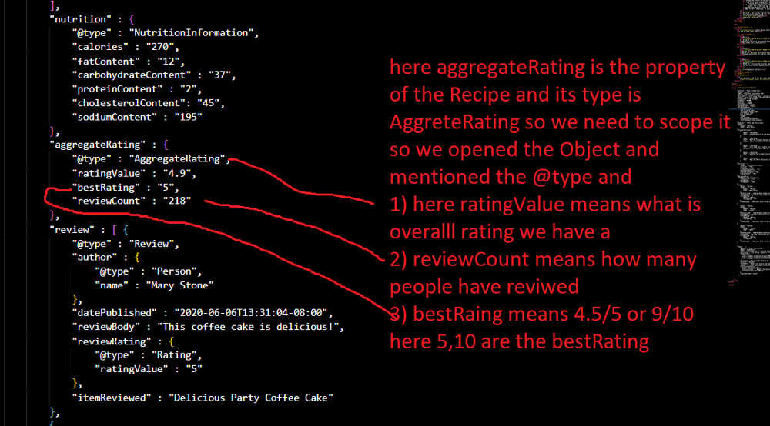2) here   
1) @content specifies what object ur using ani example scheme.org(NOTE: there are so many other website which provide scheme object preparation so we need to specify the Object)   
2) @type specifics which type thing ur using in ur code ani, like Recipe,FAQ, Events etc..   
  
3) remaing alll the property we must need according to our website content NOTE: there are some mandatory propery we need to write at anycost, while compiling these Scheme Object, google rich testing tool will suggest us and we need to write those alll properties   
  
4) for example when we write location and came to know its a sperate entry, then we need to open the Object({}i.e flow brakets) and need to specify all the property which are mandatory for us in that file THEME when u encounter a sperate entry (like address,offer) we need to open the {} and write its property

Example :   
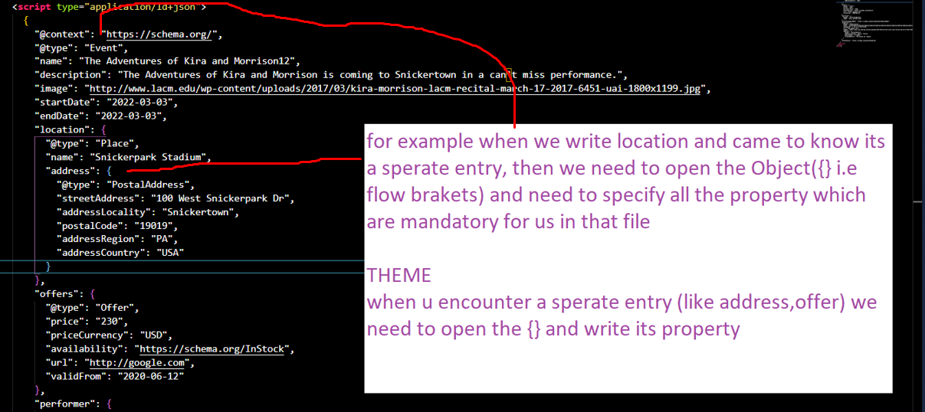  
  
Output   
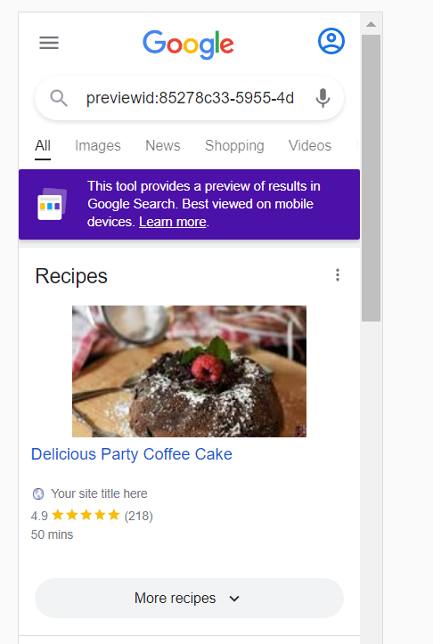

1. **RDFa Format Real Code Example**

<!**DOCTYPE** html>

<**html** lang="en">

<**head**>

    <**meta** charset="UTF-8">

    <**meta** name="viewport" content="width=device-width, initial-scale=1.0">

    <**meta** http-equiv="X-UA-Compatible" content="ie=edge">

    <**link** rel="stylesheet" href="https://stackpath.bootstrapcdn.com/bootstrap/4.3.1/css/bootstrap.min.css">

    <**title**>Delicious Party Coffee Cake</**title**>

</**head**>

<**body** class="mt-3">

    <!-- Page Content -->

    <**main** class="container" typeof="Recipe" vocab="https://schema.org/">

        <!-- Article Section -->

        <**article**>

            <**header**>

                <**h1** class="text-success" property="name">Delicious Party Coffee Cake</**h1**>

                <**p**>Recipe author: <**span** property="author">Mary Stone</**span**></**p**>

                <**p**>Date published:

                    <**meta** property="datePublished" content="2020-03-16">

                    March 16, 2020</**p**>

                <**p** property="description">This coffee cake is awesome and perfect for parties.</**p**>

                <**img** src="https://cdn.pixabay.com/photo/2019/09/24/21/49/cake-4502270_1280.jpg" height="300"

                    alt="Party Coffee Cake" property="image">

            </**header**>

            <**section** class="mt-4">

                <**h5**> Yield:

                    <**span** property="recipeYield">10 servings</**span**></**h5**>

                <**h5**> Prep time:

                    <**meta** property="prepTime" content="PT20M">

                    20 minutes </**h5**>

                <**h5**> Cook time:

                    <**meta** property="cookTime" content="PT30M">

                    30 minutes </**h5**>

                <**h5**> Total time:

                    <**meta** property="totalTime" content="PT50M">

                    50 minutes </**h5**>

                <**h5**> Category: <**span** property="recipeCategory">Cake</**span**> </**h5**>

                <**h5**> Recipe Cuisine: <**span** property="recipeCuisine"> French</**span**> </**h5**>

                <**h2** class="text-success">Ingredients</**h2**>

                <**ul**>

                    <**li** property="recipeIngredient">2 cups of flour</**li**>

                    <**li** property="recipeIngredient">3/4 cup white sugar</**li**>

                    <**li** property="recipeIngredient">2 teaspoons baking powder</**li**>

                    <**li** property="recipeIngredient">1/2 teaspoon salt</**li**>

                    <**li** property="recipeIngredient">1/2 cup butter</**li**>

                    <**li** property="recipeIngredient">2 eggs</**li**>

                    <**li** property="recipeIngredient">3/4 cup milk</**li**>

                    <**li** property="recipeIngredient">1 teaspoon vanillaextract</**li**>

                    <**li** property="recipeIngredient">1 1/2 teaspoon group cinnamon</**li**>

                </**ul**>

                <**h2** class="text-success">Directions</**h2**>

                <**ul**>

                    <**li** property="recipeInstructions" typeof="HowToStep" vocab="https://schema.org/">

                        <**span** property="text">Preheat the oven to 350 degrees F. Grease and flour a 9x9 inch pan.</**span**>

                    </**li**>

                    <**li** property="recipeInstructions" typeof="HowToStep" vocab="https://schema.org/">

                        <**span** property="text"> Make the streusal topping. In a medum bowl, combine flour, sugar, and

                            cinnamon. Mix in butteruntil the entire mixture is crumbly.</**span**></**li**>

                    <**li** property="recipeInstructions" typeof="HowToStep" vocab="https://schema.org/">

                        <**span** property="text"> In a large bowl, combine flour, sugar, baking powder, and salt. Mix in

                            the butter. Mix in the milk, egg, and vanilla. Spread into the prepared pan.</**span**></**li**>

                    <**li** property="recipeInstructions" typeof="HowToStep" vocab="https://schema.org/">

                        <**span** property="text">Sprinkle the streudal mixture on top of the cake.</**span**></**li**>

                    <**li** property="recipeInstructions" typeof="HowToStep" vocab="https://schema.org/">

                        <**span** property="text">Bake for 30 to 35 minutes, or until firm. Allow to cool.</**li**>

                </**ul**>

                <**h2** class="text-success">Nutrition facts</**h2**>

                <**p** property="nutrition" typeof="NutritionInformation" vocab="https://schema.org/">

                    Per slice :

                    <**span** property="calories">270</**span**> calories;

                    <**span** property="fatContent">12</**span**>g fat;

                    <**span** property="carbohydrateContent">37</**span**>g carbohydrates;

                    <**span** property="proteinContent">2</**span**>g protein;

                    <**span** property="cholesterolContent">45</**span**>mg cholesterol;

                    <**span** property="sodiumContent">195</**span**>mg sodium.

                </**p**>

                <**h2** class="text-success">Keywords</**h2**>

                <**p** property="keywords"> Coffe Cake, Party Cake </**p**>

            </**section**>

        </**article**>

        <!-- /.row -->

        <**hr**>

        <!-- Reviews Section -->

        <**section**>

            <**h2** class="text-success"> Sample Reviews ★★★★★ </**h2**>

            <**h6** property="aggregateRating" typeof="AggregateRating" vocab="https://schema.org/">

                <**span** property="ratingValue">4.9</**span**>

                out of

                <**span** property="bestRating">5</**span**>

                (Total <**span** property="reviewCount">218</**span**> )

            </**h6**>

            <!-- list of reviews -->

             <!-- list of reviews -->

             <**article** property="review" vocab="https://schema.org/" typeof="Review">

                <**h4** property="author">Mary</**h4**>

                <**time** datetime="2020-06-06T13:31:04-08:00">

                    <**meta** property="datePublished" content="2020-06-06T13:31:04-08:00" />

                    June 6<**sup**>th</**sup**>, 2020 at 1:31</**time**>

                <**p** property="reviewRating" vocab="https://schema.org/" typeof="Rating"> Rating:

                <**span** property="ratingValue">5</**span**> </**p**>

                <**p**>Review for: <**span** property="itemReviewed">Delicious Party Coffee Cake</**span**></**p**>

                <**p** property="reviewBody">This coffee cake is delicious!</**p**>

            </**article**>

            <**article** property="review" vocab="https://schema.org/" typeof="Review">

                <**h4** property="author">Susan</**h4**>

                <**time** datetime="2020-02-09T13:31:04-08:00">

                    <**meta** property="datePublished" content="2020-06-06T13:31:04-08:00" />

                    Feb 9<**sup**>th</**sup**>, 2020 at 1:31</**time**>

                <**p** property="reviewRating" vocab="https://schema.org/" typeof="Rating">Rating:

                   <**span** property="ratingValue">5</**span**></**p**>

                <**p**>Review for: <**span** property="itemReviewed">Delicious Party Coffee Cake</**span**> </**p**>

                <**p** property="reviewBody">The cake instructions are superbly crafted and accurately designed.</**p**>

            </**article**>

            <**article** property="review" vocab="https://schema.org/" typeof="Review">

                <**h4** property="author">Mark</**h4**>

                <**time** datetime="2020-07-16T13:31:04-08:00">

                    <**meta** property="datePublished" content="2020-06-06T13:31:04-08:00" />

                    July 16<**sup**>th</**sup**>, 2020 at 1:31</**time**>

                <**p** property="reviewRating" vocab="https://schema.org/" typeof="Rating"> Rating:

                    <**span** property="ratingValue">5</**span**> </**p**>

                <**p**> Review for: <**span** property="itemReviewed">Delicious Party Coffee Cake</**span**> </**p**>

                <**p** property="reviewBody"> The cake also includes paprika, which makes me nervous. </**p**>

            </**article**>

            <**p**><**a** href=#>(Expand all reviews)</**a**></**p**>

        </**section**>

        <!-- /list of reviews -->

        <!-- Footer -->

        <**footer** class="mt-5">

            <**hr**>

            <**p**>Copyright &copy; Home of the best cakes, 2020 |

                <**a** href="#" target="_blank" rel="nofollow">Rahul Giri</**a**></**p**>

        </**footer**>

    </**main**>

    <!-- /.container -->

</**body**>

</**html**>

**example**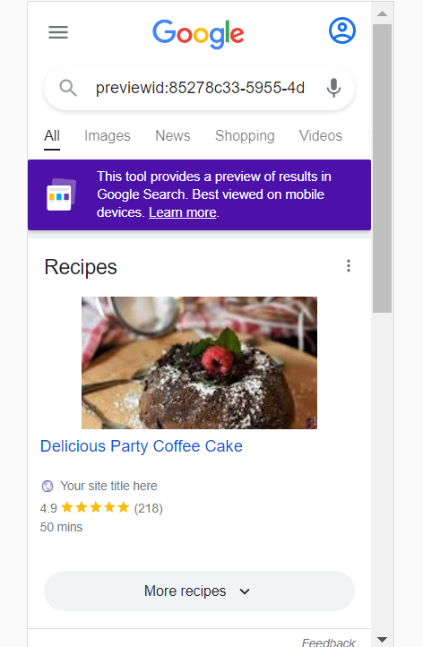

**Explanation of code  
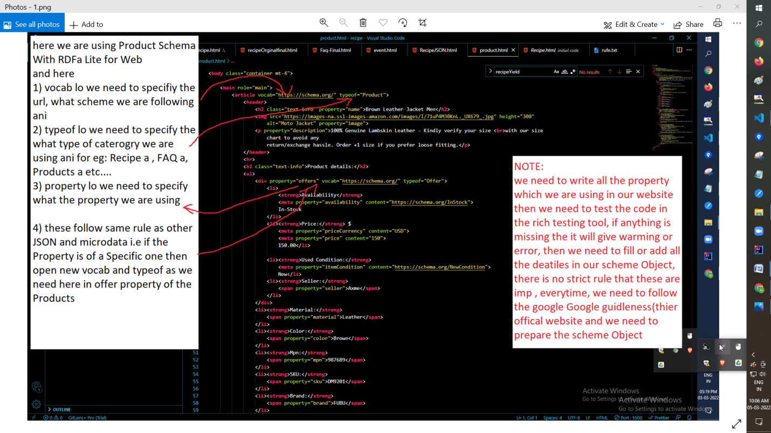**

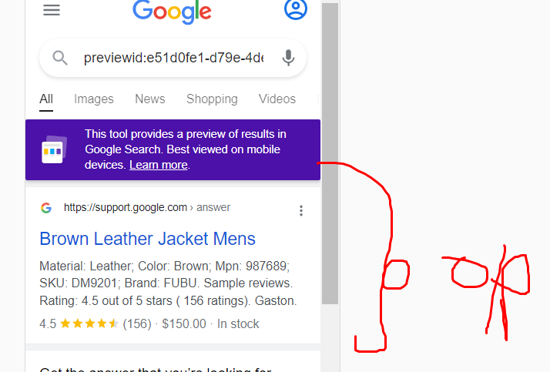

1. **#Role of the Meta tags**

Meta tags are not shown in the page, but its machine parsable it means, google robo/crawlers will use these infrormation and

Play major role in scheme Object also

1. Example :
2. <meta charset="UTF-8">  
   <title>This is the meta title tag. It can be 45-60 characters long</title>

<meta name="description" content="This is the meta description. The maximum length is somewhere around 150-160 characters, but Google often pulls a description from your page content." />  
  <meta name="keywords" content="HTML, CSS, JavaScript">  
  <meta name="author" content="John Doe">  
  <meta name="viewport" content="width=device-width, initial-scale=1.0">

1. When we don’t have any scheme Object in our project then Google will use these meta tags for displaying the rich content in the Google search for example see the below example
2. 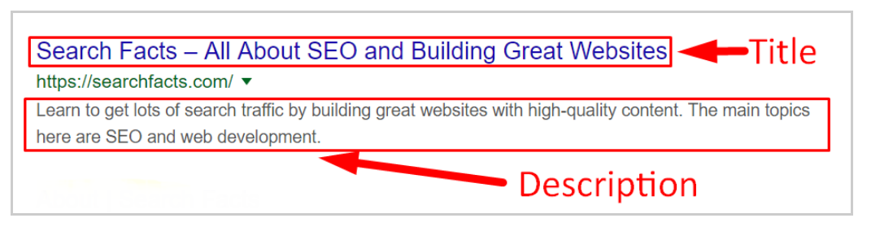
3. To learn about meta tags <https://www.w3schools.com/tags/tag_meta.asp> visist these page
4. when user type something in the google seach and when these title or description match with the user search value then our website will come in top in seach results